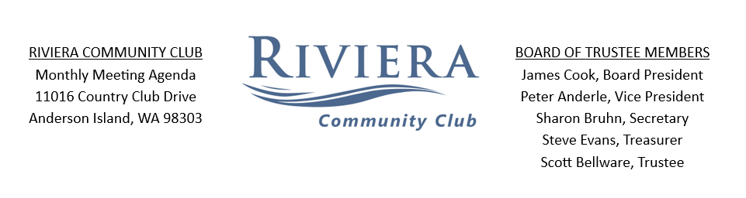
Mid-Month Meeting Agenda
July 18th, 2026 10AM
Zoom Meeting: To join this meeting visit https://us06web.zoom.us/j/4671737903?omn=88943955755
or call 253-215-8782 Meeting ID 830 4089 4487
CALL MEETING TO ORDER:
Stand for Pledge of Allegiance to the United States of America
“There is no transparency without documentation.”

- Roll Call (3 BOT Members Present Constitutes Quorum):

- MEMBER’S COMMENTS *see summary
*MEMBERS – (RCW 64.90.445) At each board meeting, the board must provide a reasonable opportunity for unit owners to comment regarding matters affecting the common interest community and the association. The board must provide at least 15 minutes at the beginning of each meeting for unit owners to comment about agenda items before the board votes. The board may place reasonable time restrictions of not less than 90 seconds per owner per unit, except that the time per owner per unit may be reduced and allocated equally if more than 10-unit owners wish to comment.

- Scope of mid-month meetings
UNFINISHED BUSINESS:
- Member comments from 6-27 meeting
  - Can comment period be at the beginning and end of BOT meetings?
  - Looking for a clear record of what happened among board members that led to the resignation of previous 3 board members and voting of 3 new board members.
- Lots for Sale & Gifted Lot
NEW BUSINESS:
- Approve Minutes from 6-27-26 Meeting
- UBS Banking Authorization signatures by each Board member.
- 2024 Audit Completed
- Election Chair Nomination
- Member Inquiries
  - Hydrofoils on Lake Josephine
  - Encroachment on Eagle Park
- ACC & Forestry
  - ACC
Request for fence and gravel driveway at 10/096 & 10/097.
Request to replace existing fence at 10/128.
Request to put up fence at 08/120 & 08/121.
Request for final approval on site development at 17/006.
Request for fence and shed at 19/005.
Request for fence at 09/018.
Request for fence at 04/117.
Motion to approve requests at recommendation of the ACC.

  - Forestry
N/A

- New Committee Member Nominees:
ACC – Don Gloyd
Compliance – Ron Postman

- Committees and Events Update: Ben Jahn
  - Compliance
    - Fireworks over 4th of July
  - Events
July 22nd – Wednesday – Key Bank Community Connections BBQ
July 24th – Friday – Midnight Bourbon concert at the Lakeshore Outdoor Stage, 6:30pm
- Treasurer’s Report: 2026-2027
Budget process update

- GM Update Dan Morgan
Schedule of Board Meetings and Town Halls
- July 25th Monthly Member meeting, followed by a town hall about proposed 2026-27 Budget.
- August 29th
- September 26th (Annual Member Meeting)
Adjournment:

